**Project Design Phase-II**

**Data Flow Diagram & User Stories**

|  |  |
| --- | --- |
| Date | 13 October 2022 |
| Team ID | PNT2022TMID44926 |
| Project Name | Smart Farmer - IOT Enabled Smart Farming Appication |
| Maximum Marks | 4 Marks |

**Data Flow Diagrams:**

A Data Flow Diagram (DFD) is a traditional visual representation of the information flows within a system. A neat and clear DFD can depict the right amount of the system requirement graphically. It shows how data enters and leaves the system, what changes the information, and where data is stored.

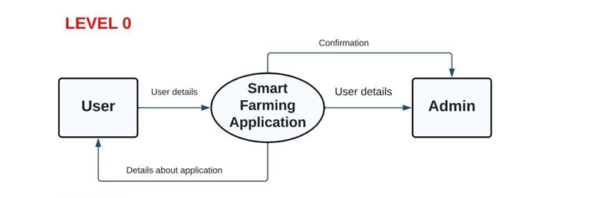

**User Stories**

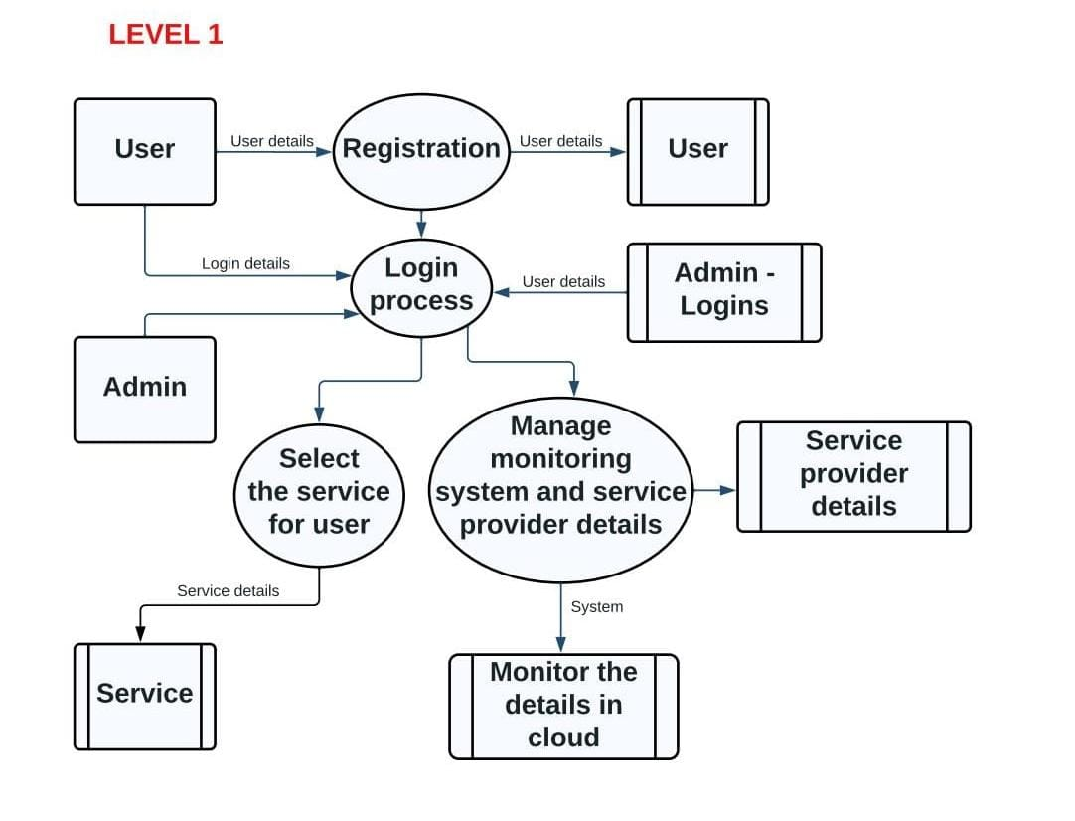

Use the below template to list all the user stories for the product.

| **User Type** | **Functional Requirement (Epic)** | **User Story Number** | **User Story / Task** | **Acceptance criteria** | **Priority** | **Release** |
| --- | --- | --- | --- | --- | --- | --- |
| Customer (Mobile user) | Registration | USN-1 | As a user, I can register for the application by entering my email, password, and confirming my password. | I can access my account / dashboard | High | Sprint-1 |
|  |  | USN-2 | As a user, I will receive confirmation email once I have registered for the application | I can receive confirmation email & click confirm | High | Sprint-1 |
|  |  | USN-3 | As a user I can register the application through Gmail | I can register & access the dashboard with Gmail Login | Low | Sprint-2 |
|  |  | USN-4 | As a user, I can register for the application through mobile number | I can registerd and access the dashboard with mobile number | Medium | Sprint-1 |
|  | Login | USN-5 | As a user, I can log into the application by entering email & password | I can acces the dashboard with email and password | High | Sprint-1 |
|  | Dashboard | USN-6 | As a user I can enter into the dashboard by using Navigational panel | I can access the dashboard by using the navigational panel | High | Sprint-1 |
| Customer (Web user) | Registration | USN-1 | As a user, I can register for the web  application by entering my email,  password, and confirming my password. | I can access my account dashboard | High | Sprint-1 |
|  |  | USN-2 | As a user, I will receive confirmation  email once I have registered for the web  application | I can receive confirmation mail then click confirm | High | Sprint-1 |
|  | Login | USN-3 | As a user I can enter into web dashboard  by using navigation panel | I can access dashboard with email login | High | Sprint-1 |
| Customer Care executive | Registration | USN-1 | As a user I can contact the customer care service through email and phone | I can receive my problem solution by sms or email | High | Sprint-1 |
|  |  | USN-2 | As a user I need to contact the customer care to answer the questions related the app product services | I can get the solution of the problem within 24 hours | High | Sprint-1 |
|  |  | USN-3 | As a user I need to registerd the complaint | I can receive my complaint confirmation message in email | High | Sprint-1 |
|  |  | USN-4 | As a user I want a customer care to troubleshoot technical problems | I can get the problem solved within 24 hours | High | Sprint-1 |
| Administrator |  | USN-1 | As a user I want admin to use good working hardware | I can get a warranty card for my product | High | Sprint-1 |
|  |  | USN-2 | As a user I want the administrator to refund my amount if I am not satisfied with the product | I can get assurance and I will get my money back within a limited time period | High | Sprint-1 |